DS Lab Tasks
Task 2:
#include <iostream>
using namespace std;

class Node {
public:
int id;
string title;
string author;
Node* next;

Node(int i, string t, string a) {
id = i;
title = t;
author = a;
next = NULL;
}
};

class LinkedList {
private:
Node* head;

public:
LinkedList() {
head = NULL;
}

void insertAtBeginning(int id, string t, string a) {
Node* newNode = new Node(id, t, a);
newNode->next = head;
head = newNode;
}

void insertAtEnd(int id, string t, string a) {
Node* newNode = new Node(id, t, a);
if (head == NULL) {
head = newNode;
return;
}
Node* temp = head;
while (temp->next != NULL)
temp = temp->next;
temp->next = newNode;
}

void insertAtPosition(int pos, int id, string t, string a) {
if (pos <= 1) {
insertAtBeginning(id, t, a);
return;
}
Node* temp = head;
int i=1;
while(temp != NULL ){
if(i<pos-1)
temp = temp->next;
else
break;
i++;
}
if (temp == NULL) {
insertAtEnd(id, t, a);
}
else {
Node* newNode = new Node(id, t, a);
newNode->next = temp->next;
temp->next = newNode;
}
}

void deleteFromBeginning() {
if (head == NULL) {
cout << "List is empty\n";
return;
}
Node* temp = head;
head = head->next;
delete temp;
}

void deleteFromEnd() {
if (head == NULL) {
cout << "List is empty\n";
return;
}
if (head->next == NULL) {
delete head;
head = NULL;
return;
}
Node* temp = head;
while (temp->next->next != NULL)
temp = temp->next;
delete temp->next;
temp->next = NULL;
}

void deleteFromPosition(int pos) {
if (head == NULL) {
cout << "List is empty\n";
return;
}
if (pos <= 1) {
deleteFromBeginning();
return;
}
Node* temp = head;
int i=1;
while(temp->next != NULL ){
if(i<pos-1)
temp = temp->next;
else
break;
i++;
}
if (temp->next == NULL) {
cout << "Position out of range\n";
return;
}
Node* delNode = temp->next;
temp->next = delNode->next;
delete delNode;
}

void searchByID(int id) {
Node* temp = head;
while (temp != NULL) {
if (temp->id == id) {
cout << "Book found:\n";
cout << "ID: " << temp->id << "\nTitle: " << temp->title << "\nAuthor: " << temp->author << "\n";
return;
}
temp = temp->next;
}
cout << "Book not found\n";
}

void display() {
if (head == NULL) {
cout << "List is empty\n";
return;
}
Node* temp = head;
while (temp != NULL) {
cout << "ID: " << temp->id << ", Title: " << temp->title << ", Author: " << temp->author << "\n";
temp = temp->next;
}
}
};

int main() {
LinkedList list;
int choice, id, pos;
string title, author;

do {
cout << "\n--- Bookstore Menu ---\n";
cout << "1. Insert at Beginning\n2. Insert at End\n3. Insert at Position\n";
cout << "4. Delete from Beginning\n5. Delete from End\n6. Delete from Position\n";
cout << "7. Search by ID\n8. Display All Books\n9. Exit\n";
cout << "Enter your choice: ";
cin >> choice;

switch (choice) {
case 1:
cout << "Enter ID, Title, Author: ";
cin >> id;
cin.ignore();
getline(cin, title);
getline(cin, author);
list.insertAtBeginning(id, title, author);
break;
case 2:
cout << "Enter ID, Title, Author: ";
cin >> id;
cin.ignore();
getline(cin, title);
getline(cin, author);
list.insertAtEnd(id, title, author);
break;
case 3:
cout << "Enter Position: ";
cin >> pos;
cout << "Enter ID, Title, Author: ";
cin >> id;
cin.ignore();
getline(cin, title);
getline(cin, author);
list.insertAtPosition(pos, id, title, author);
break;
case 4:
list.deleteFromBeginning();
break;
case 5:
list.deleteFromEnd();
break;
case 6:
cout << "Enter Position: ";
cin >> pos;
list.deleteFromPosition(pos);
break;
case 7:
cout << "Enter ID to search: ";
cin >> id;
list.searchByID(id);
break;
case 8:
list.display();
break;
case 9:
cout << "Exiting...\n";
break;
default:
cout << "Invalid choice\n";
}
}
while (choice != 9);

return 0;
}

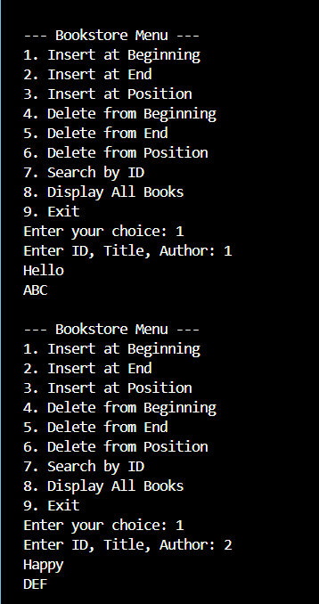
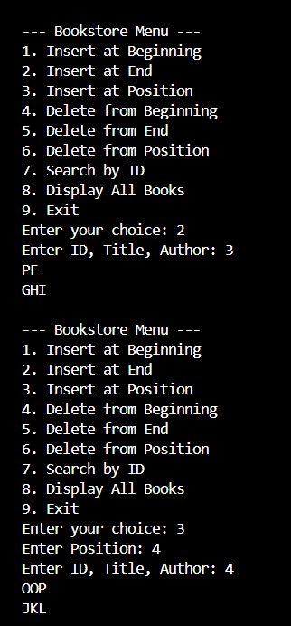
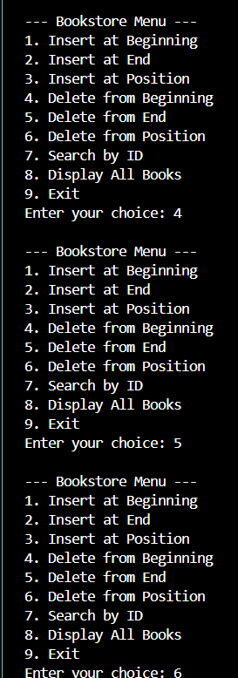
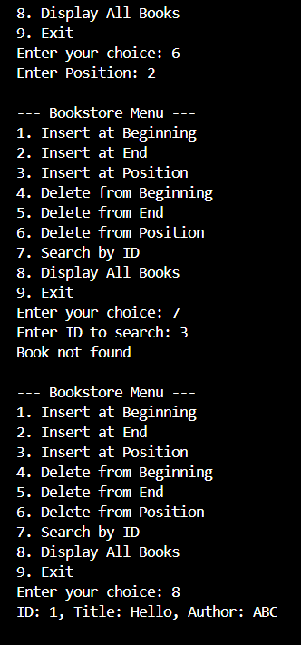
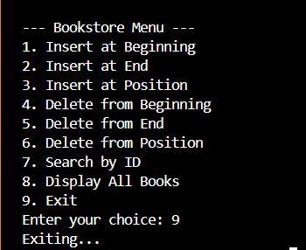

Task 3:
#include <iostream>
using namespace std;

class Node {
public:
int data;
Node* next;
Node(int val) {
data = val;
next = NULL;
}
};

class LinkedList {
private:
Node* head;

public:
LinkedList() {
head = NULL;
}

void insert(int val) {
Node* newNode = new Node(val);
if (head == NULL) {
head = newNode;
return;
}
Node* temp = head;
while (temp->next != NULL)
temp = temp->next;
temp->next = newNode;
}

void display() {
Node* temp = head;
while (temp != NULL) {
cout << temp->data;
if (temp->next != NULL) cout << " -> ";
temp = temp->next;
}
cout << " -> NULL\n";
}

void rearrangeEvenOdd() {
if (head == NULL || head->next == NULL)
return;

Node* evenHead = NULL;
Node* evenTail = NULL;
Node* oddHead = NULL;
Node* oddTail = NULL;

Node* current = head;

while (current != NULL) {
if (current->data % 2 == 0) {
if (evenHead == NULL) {
evenHead = current;
evenTail = current;
}
else {
evenTail->next = current;
evenTail = current;
}
}
else {
if (oddHead == NULL) {
oddHead = current;
oddTail = current;
}
else {
oddTail->next = current;
oddTail = current;
}
}
current = current->next;
}

if (evenHead == NULL || oddHead == NULL) {
return;
}

evenTail->next = oddHead;
oddTail->next = NULL;

head = evenHead;
}
};

int main() {
LinkedList list;
int n, val;

cout << "Enter number of elements: ";
cin >> n;

cout << "Enter elements:\n";
for (int i = 0; i < n; i++) {
cin >> val;
list.insert(val);
}

cout << "\nOriginal List:\n";
list.display();

list.rearrangeEvenOdd();

cout << "\nModified List:\n";
list.display();

return 0;
}

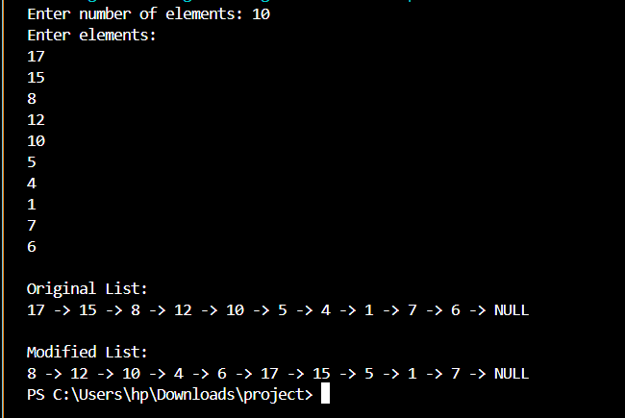
Task 4:
#include <iostream>
using namespace std;

class Node {
public:
char data;
Node* next;

Node(char c) {
data = c;
next = NULL;
}
};

class LinkedList {
private:
Node* head;

public:
LinkedList() {
head = NULL;
}

void insertChar(char c) {
Node* newNode = new Node(c);
if (head == NULL) {
head = newNode;
return;
}
Node* temp = head;
while (temp->next != NULL)
temp = temp->next;
temp->next = newNode;
}

bool checkPalindrome() {
string s = "";
Node* temp = head;
while (temp != NULL) {
s.push_back(temp->data);
temp = temp->next;
}

int i = 0, j = s.length() - 1;
while (i < j) {
if (s[i] != s[j])
return false;
i++;
j--;
}
return true;
}

void displayWord() {
Node* temp = head;
while (temp != NULL) {
cout << temp->data;
temp = temp->next;
}
cout << endl;
}
};

int main() {
LinkedList wordList;
string input;

cout << "Enter a word: ";
cin >> input;

for (int i= 0; i < input.length(); i++) {
wordList.insertChar(input[i]);
}

cout << "Word in linked list: ";
wordList.displayWord();

if (wordList.checkPalindrome())
cout << "true (Palindrome)" << endl;
else
cout << "false (Not Palindrome)" << endl;

return 0;
}

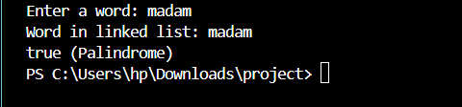
Task 5:
#include <iostream>
using namespace std;

class Node {
public:
int data;
Node* prev;
Node* next;

Node(int val) {
data = val;
prev = NULL;
next = NULL;
}
};

class Deque {
private:
Node* front;
Node* rear;

public:
Deque() {
front = NULL;
rear = NULL;
}

void insertFront(int x) {
Node* newNode = new Node(x);
if (front == NULL) {
front = rear = newNode;
}
else {
newNode->next = front;
front->prev = newNode;
front = newNode;
}
}

void insertRear(int x) {
Node* newNode = new Node(x);
if (rear == NULL) {
front = rear = newNode;
}
else {
rear->next = newNode;
newNode->prev = rear;
rear = newNode;
}
}

void deleteFront() {
if (front == NULL) {
cout << "Deque is empty\n";
return;
}
Node* temp = front;
if (front == rear) {
front = rear = NULL;
}
else {
front = front->next;
front->prev = NULL;
}
delete temp;
}

void deleteRear() {
if (rear == NULL) {
cout << "Deque is empty\n";
return;
}
Node* temp = rear;
if (front == rear) {
front = rear = NULL;
}
else {
rear = rear->prev;
rear->next = NULL;
}
delete temp;
}

int getFront() {
if (front == NULL) {
cout << "Deque is empty\n";
return -1;
}
return front->data;
}

int getRear() {
if (rear == NULL) {
cout << "Deque is empty\n";
return -1;
}
return rear->data;
}

void display() {
if (front == NULL) {
cout << "Deque is empty\n";
return;
}
Node* temp = front;
cout << "Deque: ";
while (temp != NULL) {
cout << temp->data << " ";
temp = temp->next;
}
cout << endl;
}
};

int main() {
Deque dq;

cout << "Inserting 10, 20 at front\n";
dq.insertFront(10);
dq.insertFront(20);
dq.display();

cout << "Inserting 30, 40 at rear\n";
dq.insertRear(30);
dq.insertRear(40);
dq.display();

cout << "Front element: " << dq.getFront() << endl;
cout << "Rear element: " << dq.getRear() << endl;

cout << "Deleting from front\n";
dq.deleteFront();
dq.display();

cout << "Deleting from rear\n";
dq.deleteRear();
dq.display();

cout << "Front element now: " << dq.getFront() << endl;
cout << "Rear element now: " << dq.getRear() << endl;

return 0;
}

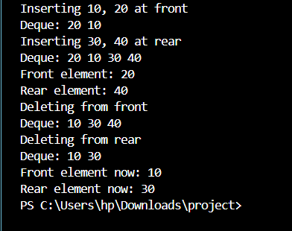
Task 6:
#include <iostream>
using namespace std;

class Node {
public:
int data;
Node* next;

Node(int val) {
data = val;
next = NULL;
}
};

class LinkedList {
public:
Node* head;

LinkedList() {
head = NULL;
}

void insert(int val) {
Node* newNode = new Node(val);
if (head == NULL) {
head = newNode;
return;
}
Node* temp = head;
while (temp->next != NULL)
temp = temp->next;
temp->next = newNode;
}

void display() {
Node* temp = head;
while (temp != NULL) {
cout << temp->data;
if (temp->next != NULL) cout << " -> ";
temp = temp->next;
}
cout << endl;
}
};

Node* mergeSortedLists(Node* a, Node* b) {
if (a == NULL)
return b;
if (b == NULL)
return a;

Node* mergedHead = NULL;
Node* mergedTail = NULL;

if (a->data <= b->data) {
mergedHead = a;
a = a->next;
}
else {
mergedHead = b;
b = b->next;
}
mergedTail = mergedHead;

while (a != NULL && b != NULL) {
if (a->data <= b->data) {
mergedTail->next = a;
mergedTail = a;
a = a->next;
}
else {
mergedTail->next = b;
mergedTail = b;
b = b->next;
}
}

if (a != NULL)
mergedTail->next = a;
else
mergedTail->next = b;

return mergedHead;
}

int main() {
LinkedList listA, listB;

cout << "List A (sorted): ";
listA.insert(1);
listA.insert(3);
listA.insert(5);
listA.display();

cout << "List B (sorted): ";
listB.insert(2);
listB.insert(4);
listB.insert(6);
listB.display();

Node* mergedHead = mergeSortedLists(listA.head, listB.head);

cout << "Merged Sorted List: ";
Node* temp = mergedHead;
while (temp != NULL) {
cout << temp->data;
if (temp->next != NULL) cout << " -> ";
temp = temp->next;
}
cout << endl;

return 0;
}

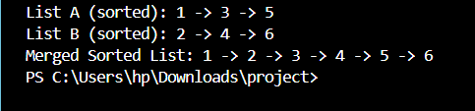
Task 7:
#include <iostream>
using namespace std;

class SNode {
public:
int data;
SNode* next;

SNode(int val) {
data = val;
next = NULL;
}
};

class DNode {
public:
int data;
DNode* prev;
DNode* next;

DNode(int val) {
data = val;
prev = NULL;
next = NULL;
}
};

class SinglyLinkedList {
public:
SNode* head;

SinglyLinkedList() {
head = NULL;
}

void insert(int val) {
SNode* newNode = new SNode(val);
if (head == NULL) {
head = newNode;
return;
}
SNode* temp = head;
while (temp->next != NULL)
temp = temp->next;
temp->next = newNode;
}

void display() {
SNode* temp = head;
while (temp != NULL) {
cout << temp->data;
if (temp->next != NULL)
cout << " -> ";
temp = temp->next;
}
cout << endl;
}

DNode* toDoublyLinkedList() {
if (head == NULL)
return NULL;

SNode* tempS = head;
DNode* headD = NULL;
DNode* prevD = NULL;

while (tempS != NULL) {
DNode* newNode = new DNode(tempS->data);
if (headD == NULL) {
headD = newNode;
}
else {
prevD->next = newNode;
newNode->prev = prevD;
}
prevD = newNode;
tempS = tempS->next;
}
return headD;
}

SNode* toCircularLinkedList() {
if (head == NULL)
return NULL;

SNode* temp = head;
while (temp->next != NULL)
temp = temp->next;
temp->next = head;

return head;
}
};

void displayDoubly(DNode* headD) {
DNode* temp = headD;
cout << "Doubly Linked List (forward): ";
while (temp != NULL) {
cout << temp->data;
if (temp->next != NULL) cout << " <-> ";
temp = temp->next;
}
cout << endl;
}

void displayCircular(SNode* headC, int count) {
cout << "Circular Linked List: ";
SNode* temp = headC;
int printed = 0;
while (temp != NULL && printed < count) {
cout << temp->data << " -> ";
temp = temp->next;
printed++;
}
cout << "(back to head...)" << endl;
}

int main() {
SinglyLinkedList sList;
sList.insert(10);
sList.insert(20);
sList.insert(30);
sList.insert(40);

cout << "Original Singly Linked List: ";
sList.display();

DNode* dHead = sList.toDoublyLinkedList();
displayDoubly(dHead);

SNode* cHead = sList.toCircularLinkedList();
displayCircular(cHead, 8);

return 0;
}

